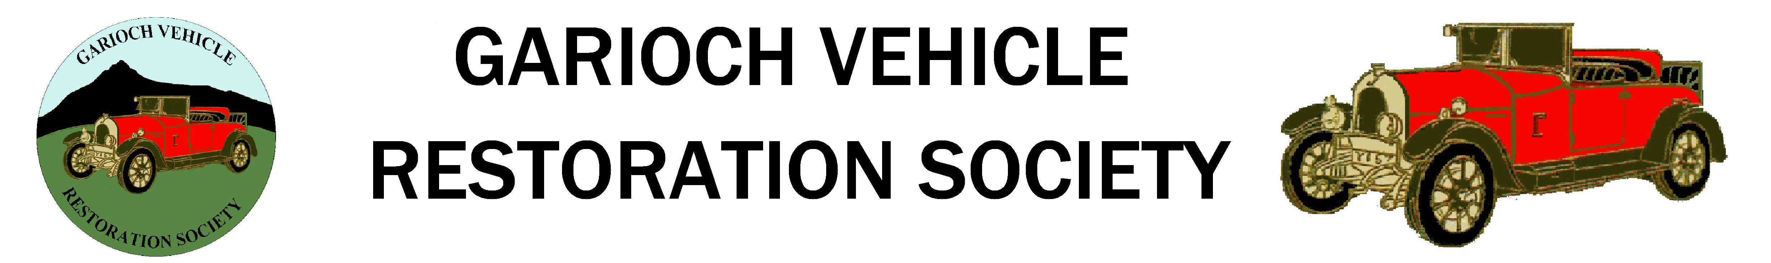
Website: www.gvrs.net

59th ANNUAL RALLY
Sunday 3rd August 2025
CHOSEN CHARITY: Clan Cancer Support
Please use the on-line form on www.gvrs.net

There will be Concours Judging and Driving Tests in Oldmeldrum Pleasure Park, followed by road runs.
ENTRY TO THE RALLY WILL BE FREE FOR ENTRANTS AND SPECTATORS
Donations for the raffle would be greatly appreciated
THERE WILL BE NO LATE ENTRIES ALLOWED
The event will be open to owners of vehicles in the following classes:

CLASS TROPHY AWARDED TO BEST ENTRY IN CLASS
1 Veteran Motor Cars to 1918 King Charles III Coronation Cup
2 Veteran Motor Cycles to 1918 Cassie Shield
3 Vintage Motor Cars 1919 -1930 Rennie/Craig Cup
4 Vintage Motor Cycles 1919 - 1930 SVVF Shield
5 Post Vintage Motor Car (1931 - 1939) Kieran Mess Memorial Cup
6 Post Vintage Motor Cycles (1931 - 1939) Harthill Trophy (Classes 2 & 6)
7 Early Classic Cars (1940 - 1958) Colin Mitchell Trophy
8a Classic Cars (1959 - 1963) Graham Fraser Trophy
8b Classic Cars (1964 - 1968) Gordon Maitland Upholstery Trophy
8c Classic Cars (1969 – 1972) John Mitchell Memorial Cup
9a Late Classic Cars (1973 – 1980) Town Council Cup
9b Late Classic Cars (1981 – 1990) Gus Main Trophy
9c Late Classic Cars (1991 – 2000) Gray & Adams 65th Anniversary Cup
10 Classic Motor Cycles (1940 - 2000) Alan Smith Trophy
11a Commercial Vehicles to 2000 (Closed bed) Gray Family Shield
11b Commercial Vehicles to 2000 (Open bed) Young Harpe Trophy
12a Agricultural Tractors to 1949 (Operational) Tractor Challenge Shield
12b Agricultural Tractors (1950 - 2000) (Operational) A.J. & D.R. Cooper Tractor Challenge Shield
13 Military Vehicles to 2000 Military Vehicle Shield
14 Bicycles to 2000 Dave Anderson Shield
15a Stationary Engines Closed Crank Wm. Munro Trophy
15b Stationary Engines Open Crank Mither Tap Challenge Salver
15c Stationary Engines Working Exhibit Alan Middleton Trophy
16 Special Interest B.H.P. Special Interest Trophy

SPECIAL AWARDS
Ben Groat Award Committee Choice for Services to GVRS
Junior Award Committee Choice for Junior Entrant
Milne Cup Best in Concours and Tests for Motorcycles
Mike Beverley Tankard Best in Concours and Tests, for car (GVRS Member only)
John Ritchie Memorial Shield Best in Car Tests
Ron Bruce Cup Best in Motorcycle Tests
I Mi’ Fin’ Trophy Best Morris Car
Gordon Maitland Upholstery Alvis Trophy Best Alvis
Jaguar Trophy Best Jaguar
LPA Motorcycle Trophy Best motorcycle of less than 100cc or any pedal assisted motorcycle.
Bob Lindsay Trophy Best Grey Ferguson Tractor
Karle Poppe Trophy Best GVRS MEMBER’S RESTORED CAR, Taxed & MOT'd where appropriate. (The car need not be in Concours condition but most of the work should have been done by the owner) (The car can only win once unless it has been substantially improved since last won.)
PROGRAMME for SUNDAY 3rd AUGUST 2025

Each ENTRANT will receive a programme, a memento and one meal discount voucher.
Entries received after the 11th July deadline will be TOO LATE for entry.
They will not be allowed entry to the Rally.
Assemble at the Pleasure Park, Oldmeldrum, AB51 0FZ, 08.00am onwards.
Register and receive your entry pack in the new Pavilion.
Concours judging from 10.00am.
Optional Tractor Road Run.
Around 1pm – Optional Road Run.
On return from the run, Featured Vehicle line up, Raffle and Prize-giving.

THE ORGANISERS ARE FULLY INSURED FOR THIS EVENT BUT ENTRANTS ARE REQUIRED, AS A CONDITION OF ENTRY, TO HAVE THEIR OWN THIRD PARTY / PUBLIC LIABILITY INSURANCE COVER................

Secretary: - Alan Sharpe Tel. 01467 621189 E-mail secretary@gvrs.net

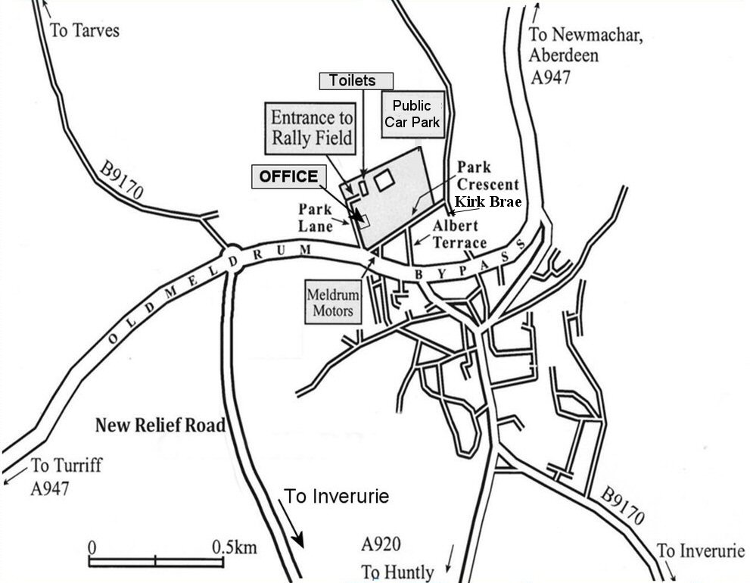

To comply with GDPR, the Secretary holds Member's information on a database. (Name, address, email & phones).
This information is used to send News, Events, Newsletters, and items for sale or requirements to the members.
All emails are sent using BCC (Blind Carbon Copy) so that no-one sees anyone else's email address.
Vehicle details are also held if you enter the Oldmeldrum Rally
The only information shared is with the SVVF if:
1. You are a Class Winner at our Rally to enter your vehicle into their National Competition.
2. You order an SVVF Yearbook to be sent to your home
If you wish to opt out notify the Secretary

Continue....
DECLARATION

1. I declare that the particulars given by me on this form are correct in every detail.

2. I declare that I have read the regulations of the event and agree to be bound by them.

3. I DECLARE THAT MY ENTRY, WHERE APPROPRIATE, IS REGISTERED, ROAD TAXED, MoT’d (where appropriate) AND HAS THIRD PARTY INSURANCE OR PUBLIC LIABILITY COVER.

4. I declare that the entry, in any of the classes defined in the regulations, existed in the year stated and is not wholly or mainly a REPLICA of later manufacture.
A REPLICA may be accepted as an entry but will NOT be judged for a Concours Award.
If the entry is a REPLICA, please state "Replica" after ‘Year and Make of Entry’.

5. I declare that I agree to accept the ruling of the stewards as final and binding.
-------------------------------------------

